NHS South West Collaborative Commissioning Hub
January 2026


Optometry Bulletin
In this Issue:

Contents………………………………………………………………………………………………………….…....1

Reminder of What to Declare to NHS England (Reg 9)..…………………………………………………………2

NHS GOS Fees & Payments and NHS Optical Voucher Values & Hospital Eye Service Charges
from April 2025………………………………………………………………………………………………………..3

Sharing Learning from an Optometry Incident…....……………………………………….………………………3

Continued Professional Development (CPD) Claims…....……………………….………………………………3

Optometry Clinical Placement Training Payment: Contractor Guidance.........………………………………...3

Temporary Suspensions.………………………………………………………………………………………...…..3

NHS Email Accounts……………………………………………………………………………….………..…..…...4

Cyber Event for Primary Care incl GP, Pharmacy, Dentistry & Optometry………..…………………………...4

Email Correspondence Signature Details ….…………………………………...……………………………...…5

Optometry Clinical Skills Guide…………………………………………………………………….…….…...........5

GOS 4 Clarification…………………………………………………………………………………………………...5

Learning From Patient Safety Events (LFPSE)………………………………………………….………………..6

GOS6 User Guide………………………………………………………………………………….….……...….…..6

Interpretation and Translation Services…………………………………………………………….….………......6

Useful Information……………………………………………………………………………….……….….………..6

Website………………………………………………………………………………………….……….….…….......6

Primary Care Support England (PCSE)………………………………………………………………....………....6

NHS Business Services Authority (NHSBSA)………………………………………………………………….….7

Reminder of What to Declare to NHS England (Reg 9)
Individuals who are included on a Performers List have a statutory duty to notify NHS England of a range of different events and situations. These include:

- Being charged with or convicted of a criminal offence in the UK, or being charged with or convicted elsewhere of an offence which would constitute a criminal offence if committed in England and Wales.
- Becoming the subject of an investigation by their regulatory body, the NHS Counter Fraud Authority, the holder of any equivalent list (i.e. the Welsh, Scottish or Northern Ireland Performers List) or in relation to any current or previous employment.
- Being informed of an adverse outcome resulting from an investigation undertaken by their regulatory body, the NHS Counter Fraud Authority, or in relation to any current or previous employment (an ‘adverse outcome’ would include any finding of fault, any warning, any finding that an individual’s performance had fallen below that of a competent practitioner, any requirement to undertake remedial actions as well as any formal regulatory or criminal action).
- Being removed or suspended from the Welsh, Scottish or Northern Ireland Performers List, being refused inclusion in any of those lists, or having conditions imposed on their inclusion in any of those lists.
- Becoming subject to a national disqualification.
- Being involved in any inquest as a person who has been found by a coroner to have caused, or contributed to, the death of the deceased or otherwise had their conduct brought into question at an inquest.
- A range of other legal actions such as being bound over following a criminal conviction, accepting a police caution (in the UK) or a fixed penalty: conditional offer by procurator fiscal or compensation offer by procurator fiscal (in Scotland), or a penalty as alternative to prosecution.

The full list of notifiable events and original wording can be found here The National Health Service (Performers Lists) (England) Regulations 2013

Any performer who is also the director of a body corporate must make a declaration to NHS England if that body corporate is subject to any of the events listed above.

It is important to note that there is no distinction between personal and professional within the list of notifiable events; for example, a criminal charge or conviction relating to events seemingly unrelated to an individual’s professional role (for example a driving offense) must still be notified to NHS England.

When any of the events listed above occurs, the performer must notify NHS England within 7 days and must provide:
a) an explanation of the facts giving rise to that matter, including those concerned, relevant dates and any outcome; and
b) copies of any relevant documents; and
c) where the event relates to a body corporate, the name and registered address of that body corporate;

If you have any queries, these should be directed through to the Professional Standards Team generic email account: england.southwestperformerslist@nhs.net

NHS GOS Fees & Payments and NHS Optical Voucher Values & Hospital Eye Service Charges from April 2025
The Department for Health and Social Care has published a letter and directions setting out general ophthalmic services fees and payments from 1 April 2025.

They have also published a letter setting out optical voucher values and hospital eye service charges from 1 April 2025.

Sharing Learning from an Optometry Incident

An incident occurred recently where a delay in a patient being seen by a health professional where an optometrist had sent a referral resulted in a significant, irreversible outcome on the patient’s health.

When referring a patient please:
• Ensure referrals are completed as soon as possible, especially if urgent intervention is needed, and ensure referrals are followed up to check they have been received and actioned.
• Recognise any risk lies with the referrer, until the onward referral has been accepted and an appointment has been offered to the patient.
• Ensure the patient understands what the referral is for, appreciates the level of concern identified, urgency of the referral and receives a copy of the referral.

Continued Professional Development Claims

The Continued Professional Development (CPD) claim window for 2025 is now open and claims can be submitted via the following link until 31st March 2026:

https://pcse.england.nhs.uk/services/ophthalmic-payments/submitting-cet-claim

The contractor who signs the CPD form needs to have had a professional relationship with the performer at some point, to ensure they are able to reasonably verify the performer’s NHS sight test activity. If a performer, delivering services within the SW, is experiencing difficulties in finding a contractor who can submit their form for them please contact us via england.optometrysouthwest@nhs.net . For performers outside the SW please ask them to reach out to the ICB team where they are delivering services. Contact details for other commissioning teams across England are available here Integrated Care Board (ICB) optometry contact email addresses

Optometry Clinical Placement Training Payment: Contractor Guidance
This guidance, published last month, sets out the arrangements for claiming the clinical placement training payment for optometry trainees undertaking clinical placements in general ophthalmic services (GOS) practices.

Temporary Suspensions
Please note that it is a contractual requirement to advise us if you are not able to fulfill your contracted GOS hours due to unforeseen circumstances such as fire, snow, flooding or staffing issues. Please inform us by sending an email to england.optometrysouthwest@nhs.net

NHS Email Accounts
Please note that you must not send any patient identifiable information via insecure email addresses. In the case where you must send patient identifiable information, please ensure that you do so using a secure NHS email address or Egress.

There are two processes for requesting a shared store email/Egress account, depending on whether the contractor has 10 practices or less, outlined below:

- GOS contractors with 10 or more practices
- Contractors to complete the form at the link below, NHSBSA will then create an Egress account on receipt of the completed MS Form:
NHS mail address/Egress request form (Page 1 of 6) (office.com)

- GOS contractors with less than 10 practices
- Contractors should contact NHSBSA on pao-support@nhsbsa.nhs.uk, to request an authentication code. Once they have the code, they will be directed by NHSBSA to complete this form https://portal.nhs.net/Registration#/optometry
Please note, if contractors complete the form without first contacting NHSBSA for the authentication code the application will not be processed.

For assistance with unlocking your NHS email account please call 0333 200 1133 or email helpdesk@nhs.net

Additional Linked nhs.net Personal Accounts

Any member of the practice team can obtain a linked nhs.net email account in order to access the shared nhs.net mailbox. These can be requested when the account is created, or by emailing the helpdesk if the shared account is already set up.

For requests please send the full name, mobile number and a personal email address for each member of the team requiring a linked nhs.net email address to helpdesk@nhs.net The request must be sent from the shared nhs.net mailbox.

If there are already 10 or more linked personal nhs.net email accounts a valid business justification for the request must also be included in the covering email.

Cyber Event for Primary Care incl GP, Pharmacy, Dentistry & Optometry
The City of London Police have a special programme to support businesses and individuals to protect themselves from cyber crime. They have partnered with NHSE to offer a series of webinars specifically for primary care organisations in England. The next event is on 10th Feb, 13:00 to 14:30 – details here and below

Microsoft Virtual Events Powered by Teams

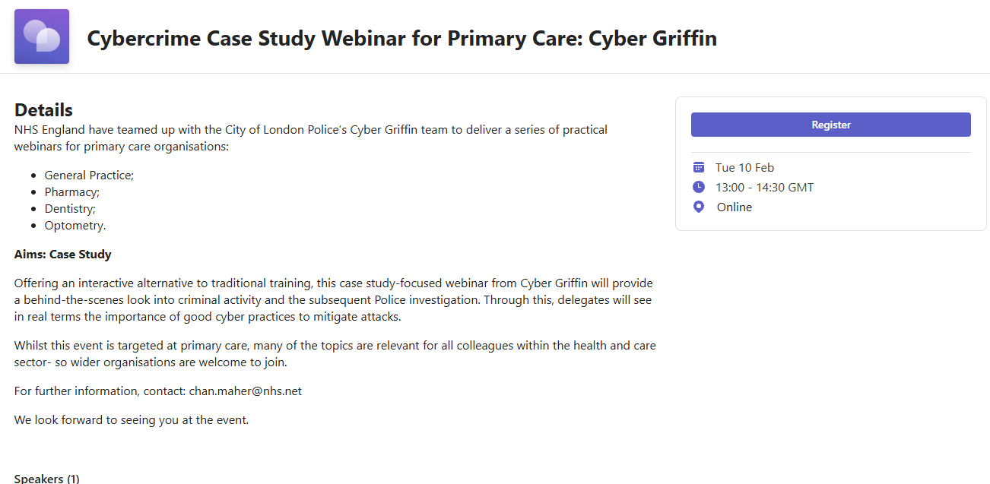

Email Correspondence – Signature Details
Please can you ensure when communicating with the South West Optometry Team you include the following details within your correspondence to help us with responding to your enquiry - Contact Name, Name of Contractor, ODS code. Thank you.

Optometry Clinical Skills Guide
Optometry Today, in collaboration with the Association of Optometrists (AOP), has released two video skills guides. One is presented by Dr Byki Huntjens, AOP education lead, exploring history and symptoms, with videos on the key questions to ask during a sight test and when carrying out a contact lens assessment. The second, led by Lorcan Butler, optical engagement manager at The Brain Tumour Charity, addresses headaches − offering guidance on recognising symptoms that may indicate serious underlying conditions, as well as practical advice on managing patients who present with migraines.

GOS 4 Clarification
When requesting a GOS 4 for an adult patient please ensure that you follow the process set out in the document below and complete the BSA pre-authorisation form.

Learning From Patient Safety Events (LFPSE)
Please find a link below to an explainer video regarding the new reporting platform, LFPSE, which is being introduced.

https://www.youtube.com/watch?v=mlRu-B-XbGM

GOS 6 User Guide

Interpretation and Translation Services
Interpretation and translation services are available for Community Optometrists when treating NHS Patients. These services are commissioned and paid for by NHS England.

This document provides details on how to currently access these services.
This information is also available to access via the NHS South West website via the following link NHS England — South West » Interpretation and Translation Services

Useful Information
NHS England – South West Region Optometry Contract Management Team

Team Member / Working Days | Telephone |  | Email Address
Michele Toy Mon - Thurs | 07568 431890 |  | england.optometrysouthwest@nhs.net
Sarah Lillington Mon - Thurs | 07920 834445 |  | england.optometrysouthwest@nhs.net
Louise Norman Mon - Fri | 07730 379362 |  | england.optometrysouthwest@nhs.net
Thomas Toogood-Smith Tues - Fri | 07551 136800 |  | england.optometrysouthwest@nhs.net
Alison French Mon - Fri | 07795 684805

Website
Jump back to the title page of this bulletin
HERE.
Please see our website for more information and any blank templates, forms and documents. The contact details for all 7 ICB Complaints Teams can also be found on this page

NHS England — South West » South West Eye Health information

Primary Care Support England (PCSE)
PCSE has the responsibility for the delivery of NHS England primary care support services.

For Opticians PCSE provides:

- Ophthalmic Payments - Administrating monthly payments of GOS forms, processing Continuing Education and Training (CET) payments, deducting local Optical Committee levies.
- Performers List - Administering entry and changes to Performers Lists on behalf of NHS England
- Supplies - Providing NHS stationery, pre-printed forms, needles and syringes via PCSE Online.

Guidance for contractors is available here: Ophthalmic Payments | PCSE (england.nhs.uk)

Contact details for PCSE

- If you have an ophthalmic payment queries you need to contact PCSE via the online contact form by using the following link: Ophthalmic Payment enquiries | PCSE (england.nhs.uk)

NHS Business Services Authority (NHSBSA)
Contact details for NHSBSA

- GOS4 Pre-authorization (for adults): pao@nhsbsa.nhs.uk
- Contract management queries: pao-cm@nhsbsa.nhs.uk
- NHS Mail/any other contractor queries: pao@nhsbsa.nhs.uk

